Seth Cram

11/03/2021

CS270: HW3

**Remove Underscores Testing**

Contents of directory before Rm_Underscores.sh run:

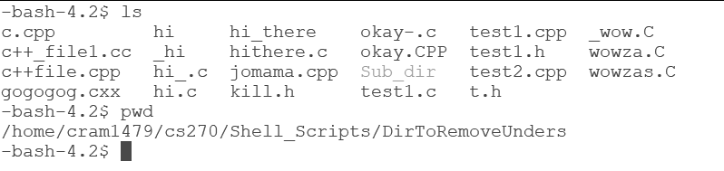

Running of Rm_Underscores.sh and resulting directory contents:

